Temperature and Humidity Testing Using the DHT 11

**DHT11 Specifications:**

· 3 to 5V power

· Max. 2.5mA during conversion

· Humidity range 20-80% with 5% accuracy

· Temperature range 0-50°C with ±2°C accuracy

**Pinout:**

· VCC (3 to 5V power)

· Data out

· GND

**Parts Required:**

You will need the following to make the circuit.

· 1 x Arduino Uno

· 1 x DHT11

· 1 x 10KΩ Resistor

· Jumper Wires

**Source Code:**

*#include "DHT.h"*

*#define DHTPIN 2 // what digital pin we're connected to*

*#define DHTTYPE DHT11 // DHT 11*

*DHT dht(DHTPIN, DHTTYPE);*

*void setup() {*

*Serial.begin(9600);*

*Serial.println("DHT11 test!");*

*dht.begin();*

*}*

*void loop() {*

*delay(2000);*

*float h = dht.readHumidity();*

*float t = dht.readTemperature();*

*float f = dht.readTemperature(true);*

*if (isnan(h) || isnan(t) || isnan(f)) {*

*Serial.println("Failed to read from DHT sensor!");*

*return;*

*}*

*float hif = dht.computeHeatIndex(f, h);*

*float hic = dht.computeHeatIndex(t, h, false);*

*Serial.print("Humidity: ");*

*Serial.print(h);*

*Serial.println("% ");*

*Serial.print("Temperature: ");*

*Serial.print(t);*

*Serial.print(" *C ");*

*Serial.print(f);*

*Serial.println(" *F\t");*

*Serial.print("Heat index: ");*

*Serial.print(hic);*

*Serial.print(" *C ");*

*Serial.print(hif);*

*Serial.println(" *F");*

*Serial.println("");*

*}*

Here’s the codes for this project.

1. Download the DHT Library from Adafruit repository.

2. Unzip the DHT library and rename the extracted folder to DHT.

3. Copy this folder to the following path to install the DHT library.

C:\Program Files (x86)\Arduino\libraries

4. Upload below code.

You should see the humidity and temperature on the serial monitor once the sketch has been successfully uploaded to Arduino.

**GUI**

I used Visual Studio 2015

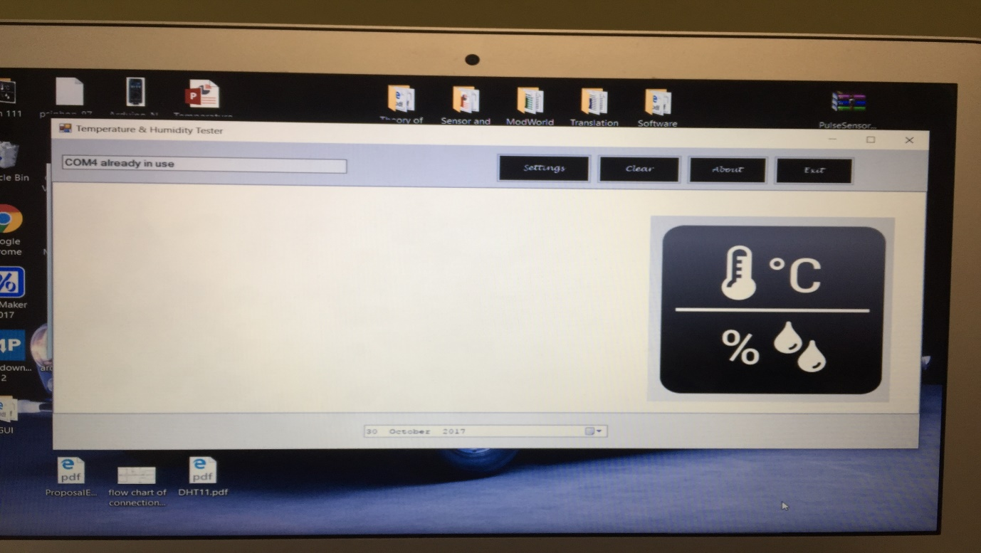

I posted the code and the files that you can just compile and run in Visual Studio 2015 for this GUI.